Personal Insurance, Inc.

Shelly Cashman Access 2019 | Module 4: SAM Project 1a



Creating Reports and Forms

# GETTING STARTED

* ~~Open the file~~ **~~SC_AC19_4a_~~*~~FirstLastName~~*~~_1.accdb~~**~~, available for download from the SAM website.~~
* ~~Save the file as~~ **~~SC_AC19_4a_~~*~~FirstLastName~~*~~_2.accdb~~** ~~by changing the “1” to a “2”.~~

~~If you do not see the .accdb file extension in the Save As dialog box, do not type it. The program will add the file extension for you automatically.~~

* ~~Open the~~ **~~_GradingInfoTable~~** ~~table and ensure that your first and last name is displayed as the first record in the table. If the table does not contain your name, delete the file and download a new copy from the SAM website.~~
* PROJECT STEPS

1. ~~Personal Insurance, Inc. is a national company that insures homeowners and renters. As a regional manager, you need to be able to prepare reports for other managers and create forms that help in making database updates.   
     
   Open the~~ *~~Regional Customer Report~~* ~~in Layout View. Group the report by the~~ *~~Region~~* ~~field, and then sort the report by the~~ *~~CustomerID~~* ~~field in~~ **~~ascending~~** ~~order. Do not add any additional grouping or sorting options to the report. Close the Group, Sort, & Total pane, then save and close the report.~~
2. ~~Open the~~ *~~Renter Policy Report~~* ~~in Layout View, and modify the report as follows:~~
   1. ~~Average the values in the~~ *~~PersonalProperty~~* ~~column and sum the values in the~~ *~~Premium~~* ~~column.~~
   2. ~~Switch to Print Preview to view the report and to check that the values in the subtotal controls and the total controls are not truncated (cut off) vertically.~~
   3. ~~Return to Layout View, and, if necessary, drag the sizing handles for the subtotal control and the total control down so that the values display completely.  
        
      Save the report without closing it.~~
3. ~~With the~~ *~~Renter Policy Report~~* ~~still open in Layout View, apply~~ **~~conditional formatting~~** ~~to the~~ *~~Premium~~* ~~column. If the premium amount is greater than $225, display the value in~~ **~~bold~~**~~,~~ **~~Maroon~~** ~~font (6th column, 1st row of the Standard Colors palette).  
   Save the report again, confirm that it matches Figure 1, and then close it.~~

* Figure 1: Renter Policy Report

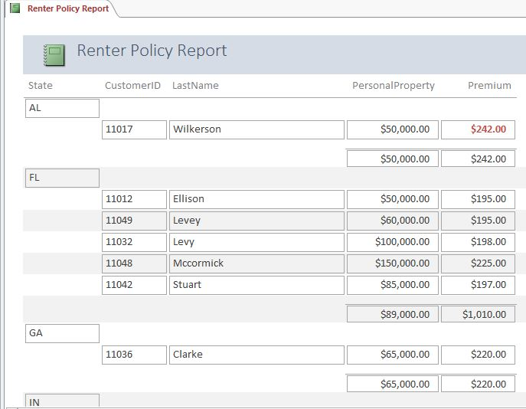

1. ~~Open the~~ *~~NE Homeowners Report~~* ~~in Layout View, and then create a summary report. Save and close the report.~~
2. ~~Open the~~ *~~Customer Contact Report~~* ~~in Layout view. Apply the~~ **~~Office~~** ~~theme to this object only. Save and close the report.~~
3. ~~Use the Label Wizard to create mailing labels for the~~ *~~Customers~~* ~~table, and include the following options:~~ 
   1. ~~Use~~ **~~Avery C2163~~** ~~as the label size.~~
   2. ~~Use~~ **~~Arial~~** ~~font,~~ **~~11 point~~** ~~font size,~~ **~~Light~~** ~~font weight, and~~ **~~Black~~** ~~(1st column, 6th row of the Basic Colors palette) font color with no special font styles for the labels. (~~*~~Hint~~*~~: These formatting options may be the default settings for your label.)~~
   3. ~~On the first line of the label, include the~~ *~~FirstName~~* ~~field, a space, and the~~ *~~LastName~~* ~~field.~~
   4. ~~On the second line of the label, include the~~ *~~Address~~* ~~field.~~
   5. ~~On the third line of the label, include the~~ *~~City~~* ~~field, a comma (,), a space, the~~ *~~State~~* ~~field, a space, and the~~ *~~PostalCode~~* ~~field. Your label should match Figure 2.~~
   6. ~~Sort the labels by the~~ *~~PostalCode~~* ~~field.~~
   7. ~~Save the report as~~ **~~Labels Customers~~** ~~(which is the default name).  
        
      Preview the report, confirm that it matches Figure 3, and then close it.~~

* Figure 2: Prototype Customers Label

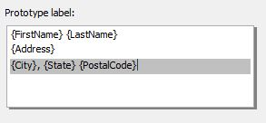

* Figure 3: Labels Customer Report

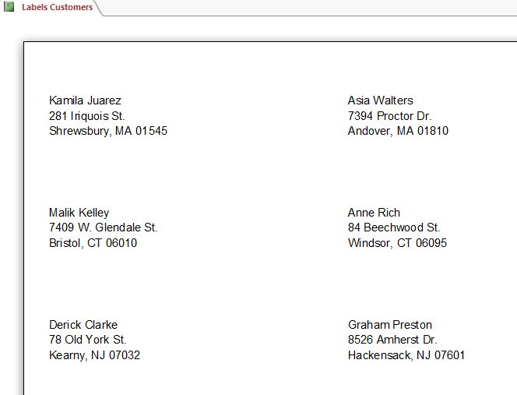

1. ~~Use the Report Wizard to create a report based on the~~ *~~Customers~~* ~~and~~ *~~Renters~~* ~~tables. The report should include the following options:~~
   1. ~~Include the~~ *~~CustomerID~~* ~~and~~ *~~LastName~~* ~~fields from the~~ *~~Customers~~* ~~table.~~
   2. ~~Include the~~ *~~PolicyNumber~~* ~~and~~ *~~Premium~~* ~~fields from the~~ *~~Renters~~* ~~table.~~
   3. ~~The data will automatically be grouped by the~~ *~~CustomerID~~* ~~and~~ *~~LastName~~* ~~fields, but do not add any additional grouping levels.~~
   4. ~~Sort the report by the~~ *~~PolicyNumber~~* ~~field in~~ **~~ascending~~** ~~order.~~
   5. ~~Use the~~ **~~Stepped~~** ~~layout and~~ **~~Portrait~~** ~~orientation.~~
   6. ~~Save the report using~~ **~~Customers and Renters Report~~** ~~as the report name.  
        
      Preview the report, confirm that it matches Figure 4, and then close it.~~

* Figure 4: Customers and Renters Report

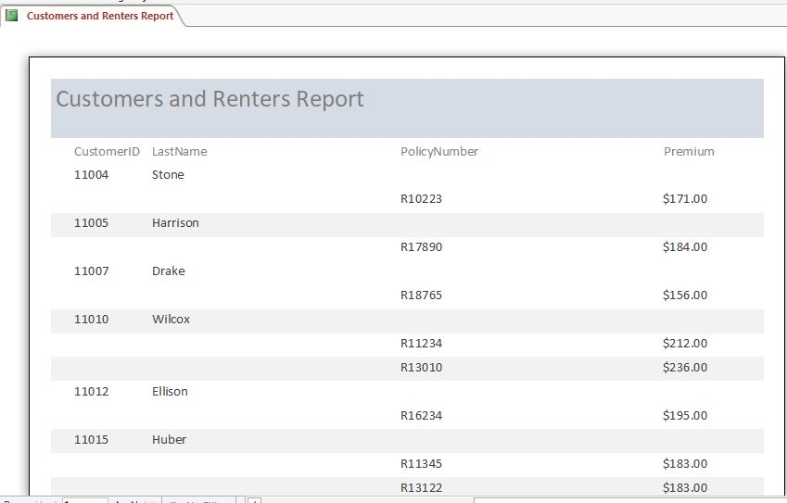

1. ~~Open the~~ *~~Customer BirthDate~~* ~~Form in Layout View, and then modify the form by performing the following tasks:~~
   1. ~~Select all labels and controls in the Detail section of the form. (~~*~~Hint:~~* ~~Do not select the form title label in the Form Header section.) Place the selected controls in a~~ **~~Stacked~~** ~~control layout.~~
   2. ~~Add the~~ *~~DateOfBirth~~* ~~control to the end of the form after the~~ *~~State~~* ~~control as shown in Figure 5.~~
   3. ~~Move the~~ *~~LastName~~* ~~control after the~~ *~~FirstName~~* ~~control as shown in Figure 5. (~~*~~Hint:~~* ~~Be sure to select both the label and the control for the~~ *~~LastName~~* ~~field.)  
        
      Save and close the form.~~

* Figure 5: Customer BirthDate Form

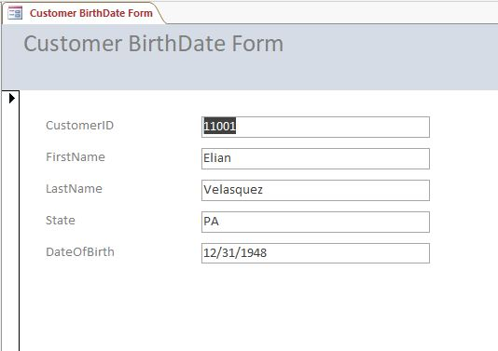

1. ~~Open the~~ *~~Claims Update Form~~* ~~in Layout View, and then~~ **~~bold~~** ~~the~~ *~~Paid~~* ~~control. Save and close the form.~~
2. ~~Open the~~ *~~Umbrella Update Form~~* ~~in Layout View, and then add the current date to the form. Use the option button for the second date format. Do not include the time on the form. Save and close the form.~~
3. ~~Use the Form Wizard to create a form based on the~~ *~~Homeowners~~* ~~table with the following options:~~
   1. ~~Include the~~ *~~CustomerID~~*~~,~~ *~~PolicyNumber~~*~~,~~ *~~PropertyDamage~~*~~,~~ *~~Liability~~*~~, and~~ *~~Premium~~* ~~fields (in that order) on the form.~~
   2. ~~Select the~~ **~~Columnar~~** ~~layout for the form.~~
   3. ~~Save the form using~~ **~~Homeowner Premium Form~~** ~~as the form name.  
        
      Close the form.~~

Save and close any open objects in your database. Compact and repair your database, close it, and then exit Access. Follow the directions on the SAM website to submit your completed project.